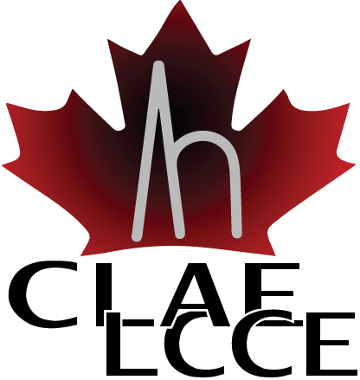

Wilder Penfield Award

The CLAE is pleased to announce the call for the 2019 Wilder Penfield Gold Medal Award, which has been a tradition for the CLAE since 1982 (See below for prior awardees).

It honours a CLAE member for outstanding lifetime clinical and/or research contributions in epilepsy. Both the nominee and the nominator must be CLAE members in good standing.

The following will be considered when evaluating the nominees:
- Previous awards/honours
- Publication record (as lead or senior author and can include reports if the individual is not a researcher)
- Leadership in the field (invited speaker/moderator, clinical activities, public health, commercialization)
- Professional and other service type activities (e.g. committees, review of manuscripts, review of grants/awards, community involvement in support of epilepsy, etc.)
- Supervisory activities/graduate committees/other training of future leaders in their field.
- Nomination letter

Submission deadline for nomination is Monday August 19, 2019.
Please note: Prior awardees are not eligible to be nominated for the Wilder Penfield Award again.

Nomination package must include:

- A letter of recommendation (maximum 2 pages) outlining why the nominee is deserving of this award.
- Nominee’s curriculum vitae (CV)
- Nomination form

Wilder Penfield Award Nomination Form

Name of Nominee:
Institution:
Mailing Address:
City | Province |  | Postal Code
Phone | Fax
Email Address
Name of Nominator:
Institution:
Mailing Address:
City | Province |  | Postal Code
Phone | Fax
Email Address

Please send the completed nomination form with required attachments electronically or by fax to: Dr. Francois Dubeau clae@secretariatcentral.com.

Prior Awardees
  - 1982 Theodore Rasmussen
  - 1984 Brenda Milner
  - 1986 Preston Robb
  - 1987 Katherine and Julius Metrakos
  - 1988 Juhn Wada
  - 1990 Pierre Gloor
  - 1997 Warren Blume
  - 1999 Frederick Andermann

- 2001 Jean-Marc St Hilaire
- 2003 Peter Camfield
- 2005 Brenda Milner
- 2006 Jean Gotman
- 2008 Jean Reiher
- 2014 Carter Snead
- 2015 Richard McLachlan
- 2017 Massimo Avoli

